Performance > Performance Trackers

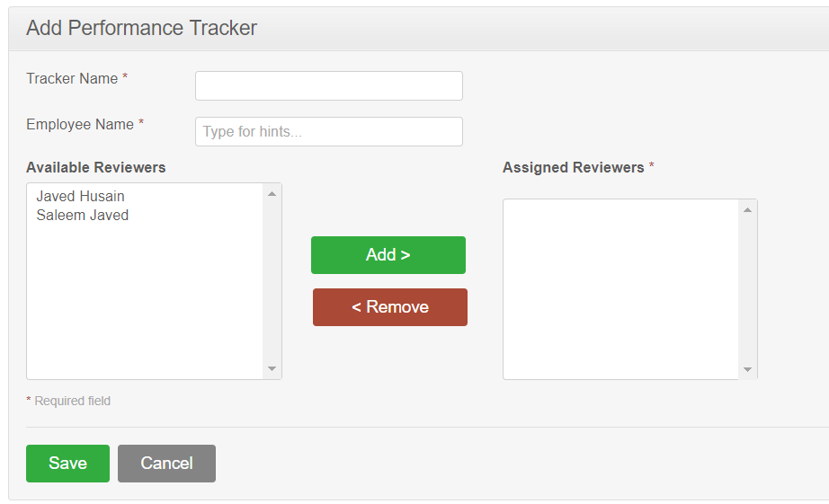Bottom of Form

Search List

